SELECT * FROM public."Doctor" CROSS JOIN public."Doctor_Specialization";
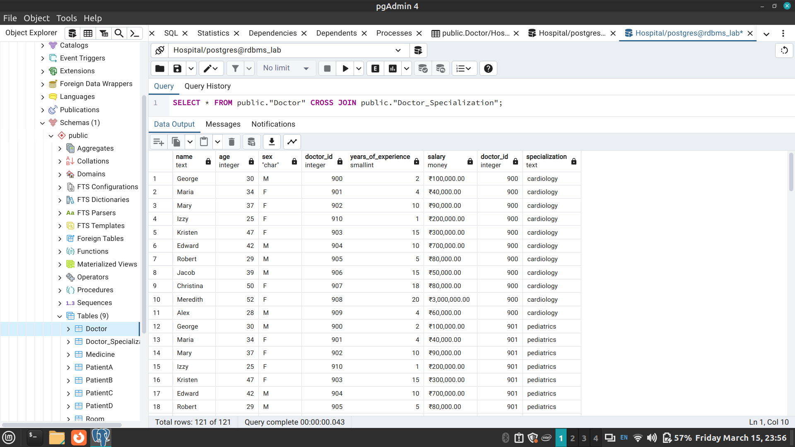
SELECT * FROM public."Doctor" INNER JOIN public."Doctor_Specialization" ON "Doctor".doctor_id = "Doctor_Specialization".doctor_id;
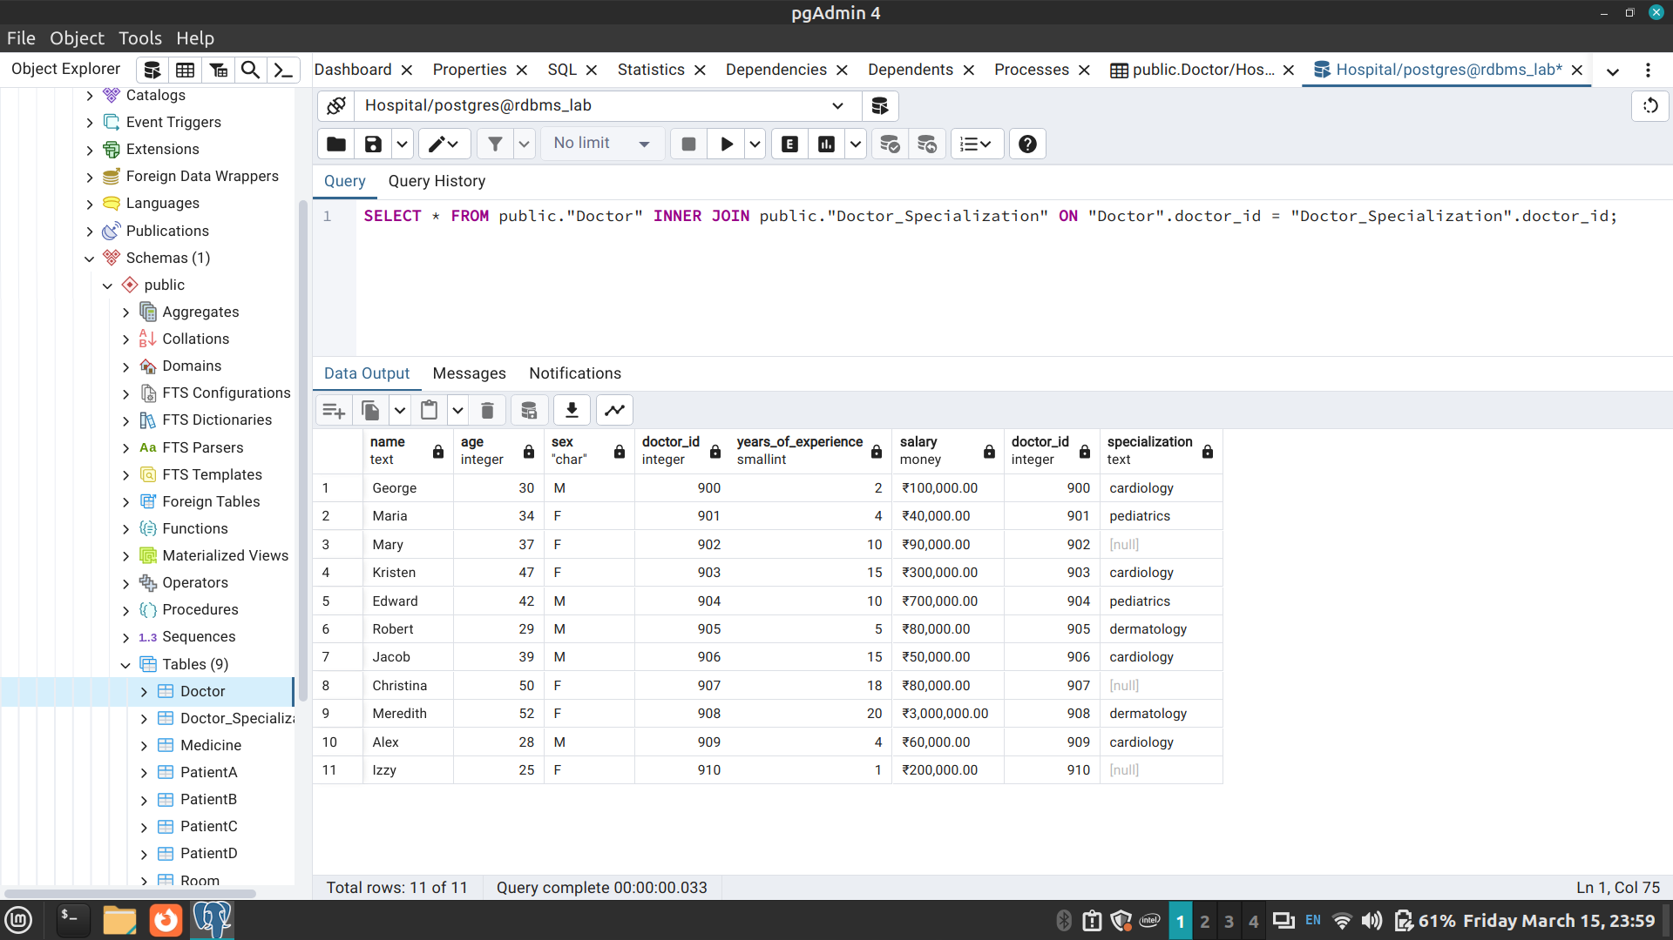
SELECT * FROM public."Doctor" LEFT OUTER JOIN public."Doctor_Specialization" ON "Doctor".doctor_id = "Doctor_Specialization".doctor_id;
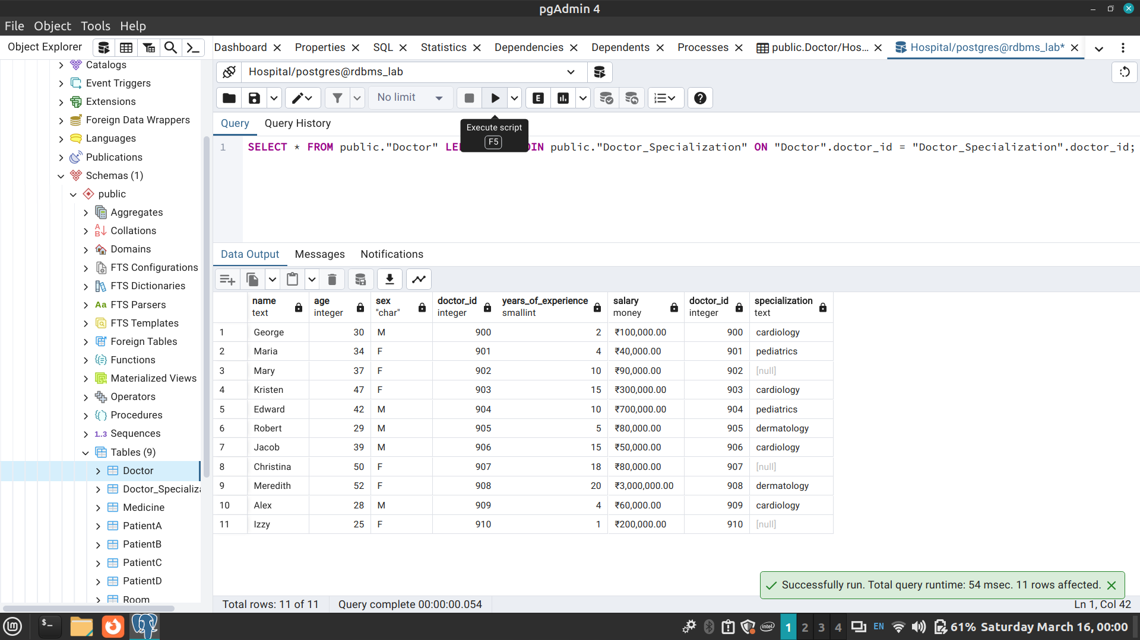
SELECT * FROM public."Doctor" RIGHT OUTER JOIN public."Doctor_Specialization" ON "Doctor".doctor_id = "Doctor_Specialization".doctor_id;
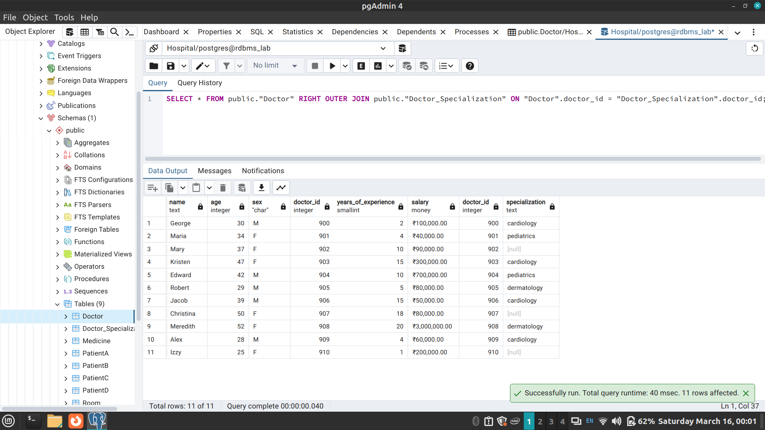
SELECT * FROM public."Doctor" FULL OUTER JOIN public."Doctor_Specialization" ON "Doctor".doctor_id = "Doctor_Specialization".doctor_id;
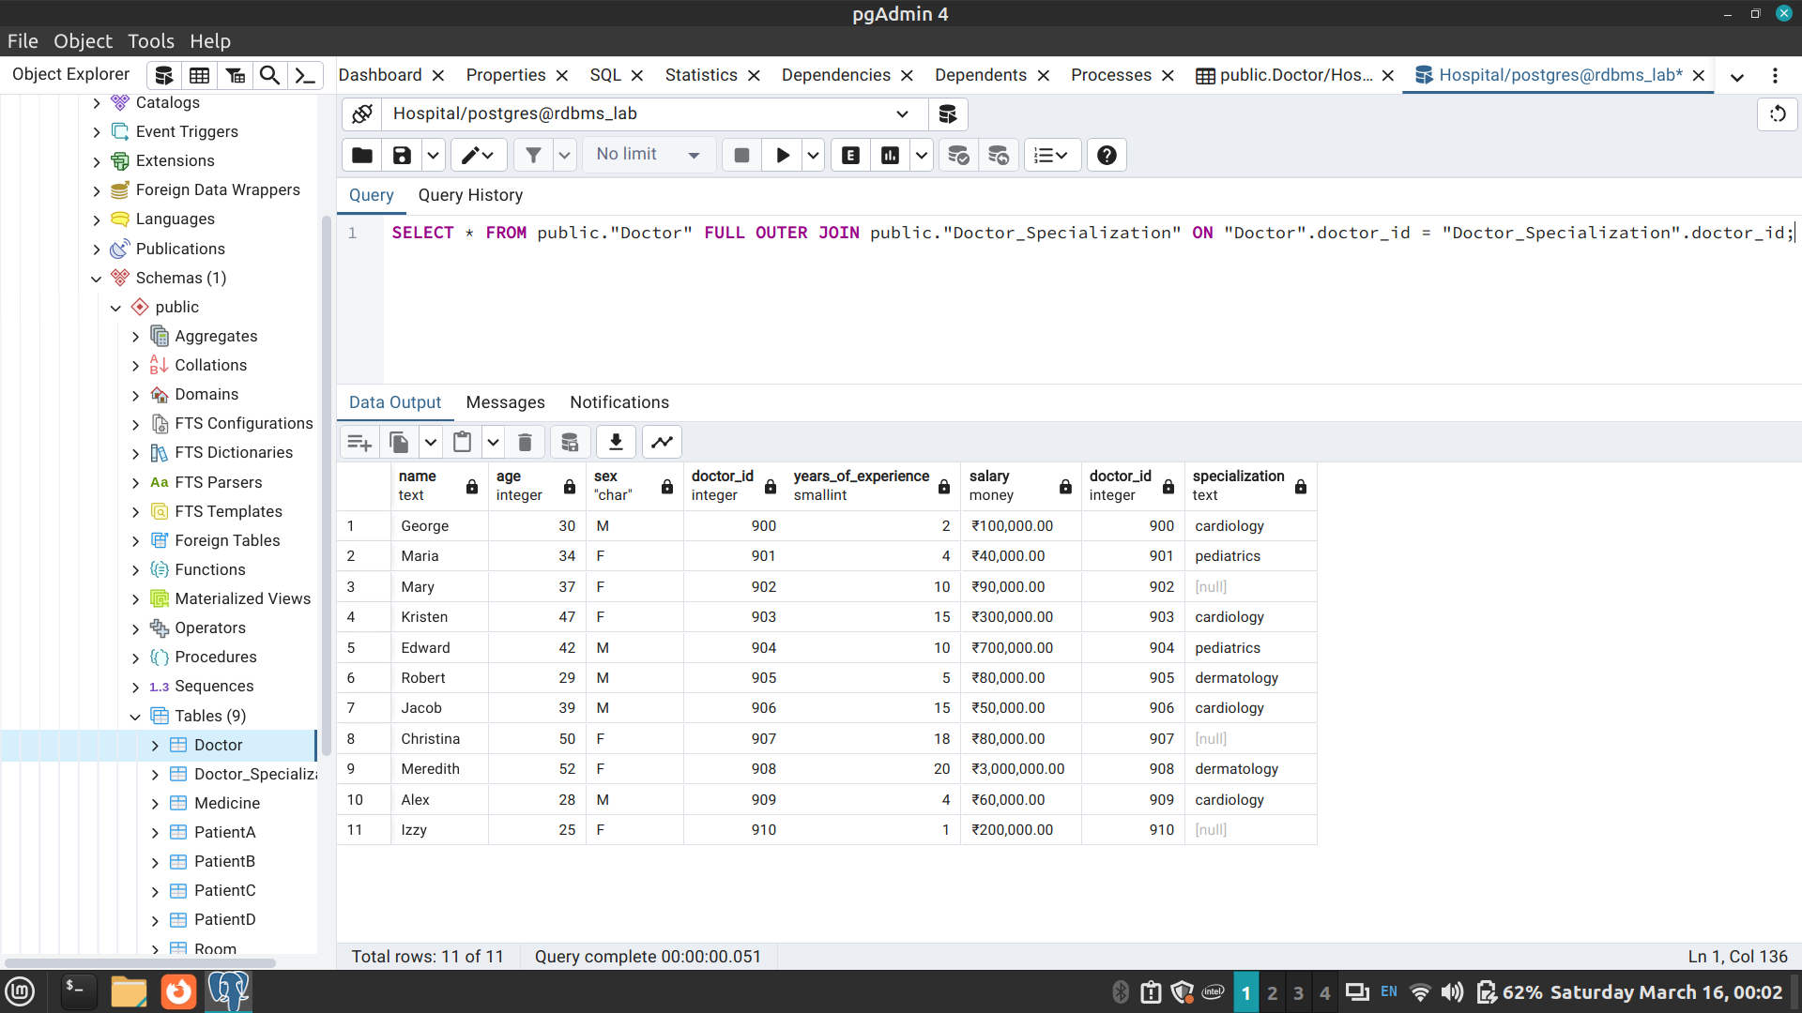
CREATE VIEW patient_info
AS SELECT name, patient_id, date_admitted, bill_amount
FROM public."PatientB";
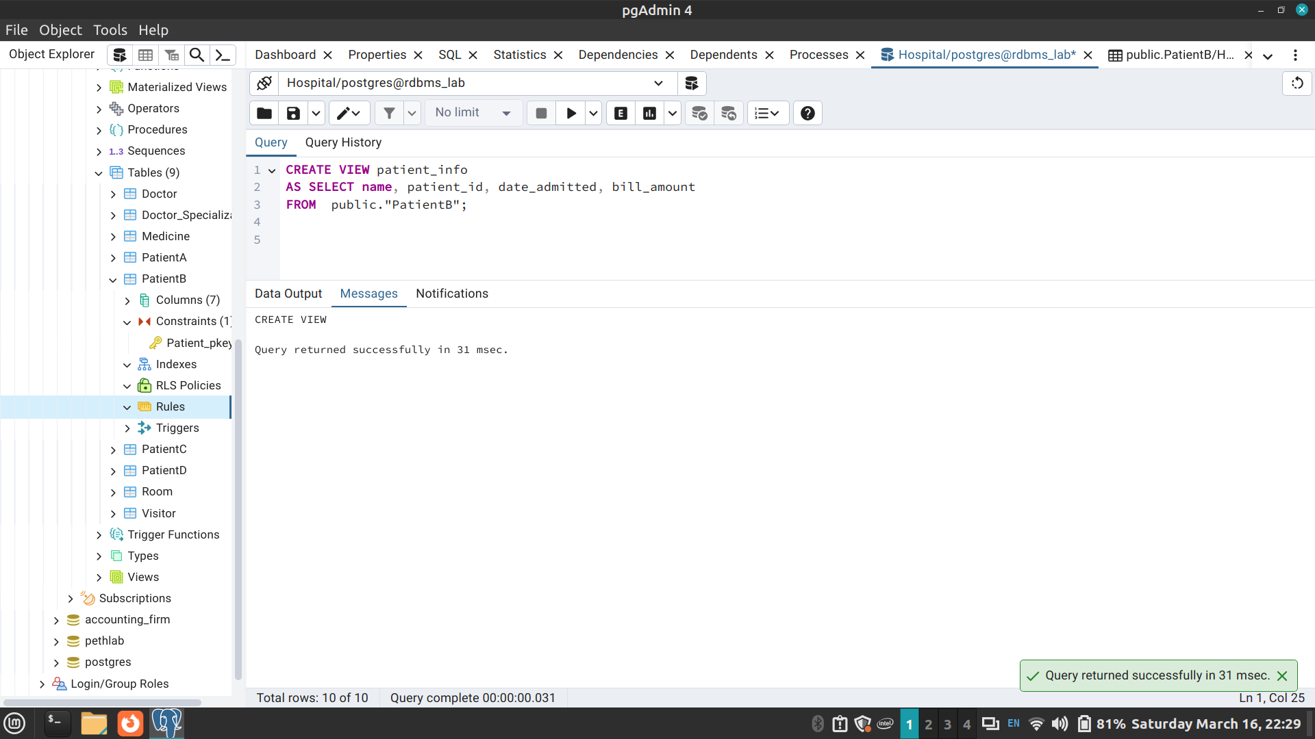
SELECT * FROM patient_info_receptionist
